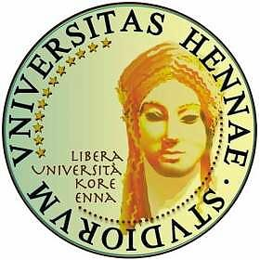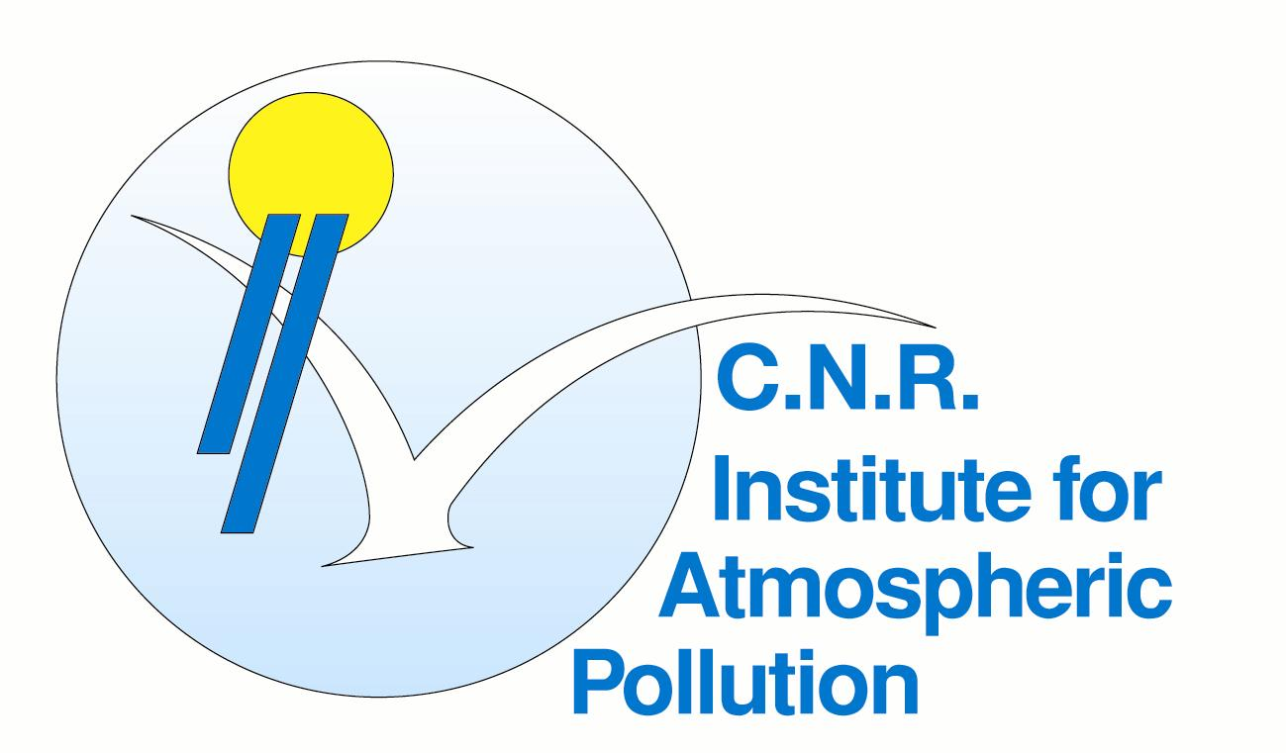

2nd INTERNATIONAL SUMMER SCHOOL
Climate changes in the Mediterranean area

Leonforte (EN), Villa Gussio, 11 - 15 September 2009

Since the ‘80s the international scientific community understood that climate change represents a global problem. However, this problem shows distinct features in distinct regions of the world. Observational and modelling studies first concentrated on global investigations, but at present they are specialising in order to understand climate dynamics and its impacts on ecosystems just at this regional scale.
In this framework, Kore University in Enna (Sicily, Italy) organizes this 2nd Summer School with the aim at introducing the knowledge of observed and forecast climate changes and at deepening two specific topics: the modelling of climate changes and related impacts in the Mediterranean area, the technologies and good practices for mitigation and adaptation.
This allows young researchers and students with a scientific degree to get in touch directly with some of the major experts in this field and with their research lines, both during lessons related to specific topics and during exercise sessions and excursions.
All the activities will be held in the peaceful framework of Villa Gussio.

SCIENTIFIC COMMITTEE

Giovanni Tesoriere (Kore University, Enna) – School Coordinator

Antonello Pasini (CNR, Rome) – Scientific Director of the School
Fabrizio Antonioli (ENEA, Rome)
Pedro Berliner (Tel Aviv University, Israel)
Massimo Capaldo (Head of the Italian Met Service, Rome)
Carlo Carraro (Department of Economic Sciences, “Ca’ Foscari” University, Venice)
Mauro Cristaldi (Department of Animal and Human Biology, “La Sapienza” University, Rome)
Filippo Giorgi (International Centre for Theoretical Physics, Trieste)
Gaetano Lanzalone (Kore University, Enna)
Vincenzo Liguori (Department of Engineering, University of Palermo)
Maurizio Maugeri (Department of Physics, University of Milan)
Francesco Tubiello (JRC, Ispra)
Aurora Tumino (Kore University, Enna)

LOCAL ORGANIZING COMMITTEE
Franco Colombo (Kore University, Enna)
Gaetano Lanzalone (Kore University, Enna)
Vincenzo Liguori (University of Palermo)
Dario Ticali (Kore University, Enna)
Aurora Tumino (Kore University, Enna)

OUTLINE OF THE PROGRAM
The School will be held in the period 11-15 September 2009 in Villa Gussio at Leonforte (EN). It is organized in frontal lessons for acquiring techniques and discussing the results achieved in the various fields, exercises for deepening topics about data analysis and modelling, and finally excursions for verifying dynamics of past climate change as far as vertical relative movements of the sea level are concerned.

The program is divided into two parts.
The first part is introductory, common to all attendants. General observational and modelling topics will be dealt with in this part:
- historical climatology: ice-cores (EPICA project), satellite observations of the water cycle, observations at the surface in the Mediterranean area, sea level and coasts;
- modelling approaches for understanding climate dynamics;
- GCMs and regional models (RCMs).
The second part of the program runs on two parallel sessions.
The first session is devoted to “Regional/local modelling and impact models in the Mediterranean area”, with the following topics:
- reconstructions of past climate and projections in the Mediterranean area by modelling;
- impact models on the agricultural activities;
- impact models on the economic activities.
The second session is devoted to “Technologies and good practices of mitigation and adaptation” to be adopted in order to fight the future climate change and the most dangerous impacts, with the following topics:
- CO₂ geological confinement;
- towards “ecological” air-conditioners: the CNR experience;
- desertification in the Mediterranean area: a Israeli experience;
- protected areas: an attempt at safeguarding biodiversity in the Mediterranean area.

Lessons will be directly held by the members of the Scientific Committee or by other major experts in the field (a complete list of Lecturers will be supplied as soon as possible).

Participants will receive introductory didactical material and each Lecturer will distribute papers for allowing a deepen insight of the topics. A final certificate will be issued to all participants at the School.

Student profile
This Summer School is devoted to young researchers and students in scientific disciplines (a maximum of 30 students will be allowed). A brief CV will be required at the submission of the participation request and the chosen parallel session must be clearly indicated. If this request will be accepted, the payment of 250 Euros will be due in order to cover the organization coasts. Financial support for a limited number of participants from developing countries is available.

Deadline for application:
30 June 2009

Further information:
News about the School will be posted on the web site www.unikore.it

Useful addresses:
Scientific Director (A. Pasini): pasini@iia.cnr.it
Scientific secretary (M. Giusto): scuolaestiva@iia.cnr.it
Administrative secretary (G. Gentile): gaspare.gentile@unikore.it

